Assembly Program 1

Program 1 Improvements/ Changes

1. Created main procedure and independent procedures separate. In my first revision, the whole program was a long main procedure that went straight through each instruction. I created independent procedures, such as with converting and printing hexadecimal and binary. I created a main procedure list to work through each.
2. Primitive pay calculator. I created a procedure to ask for your hours worked in a week and your hourly pay rate to provide an integer estimate of pay.
3. Change of color & background. I added a few lines to change the background color and text color.

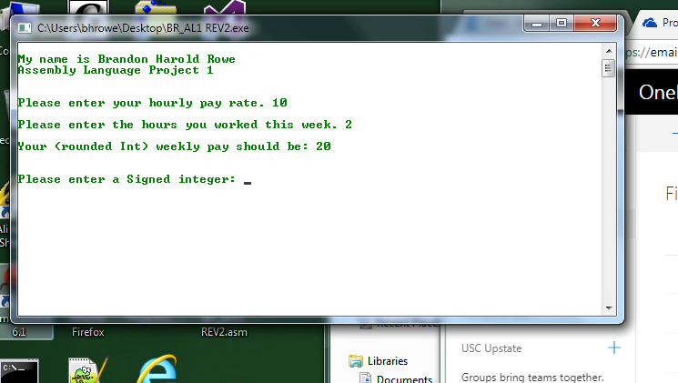

My program would not run through the main procedure as the parameters set by me. It would invoke the exit process after the 3rd or 4th procedure. For my pay calculator, I originally wanted to create one that would calculate overtime and precise decimal values that proved to be difficult.